Дата: 06.11.2023 Клас: 7-Б

Предмет: Англійська мова

Тема: Виконуємо домашню роботу самі.

Мета: формувати навички вживання нових лексичних; вдосконалювати навички читання й мовлення з опорою на лексико-граматичні структури; розвивати мовну здогадку й мовленнєву реакцію учнів; виховувати зацікавленість у розширенні своїх знань.

Вчитель: Глуговська Л.Г.

**Хід уроку**

***1.Greeting***Good afternoon, dear children! I’m glad to see you. Are you ready to start our lesson? Let’s start.

***2.Warming up***

***Do the quiz:***

***<https://wordwall.net/resource/13476811/household-chores-quiz>***

***3. Check hometask***

Choose the correct answers:

1. …….. used my laptop yesterday. I need to know who did it.

a. Somebody

b. Nobody

c. Anybody

1. It happened very quickly and I couldn't see _____.

a. nothing

b. something

c. anything

1. Have you talked to _____ about your health problems?

a. somebody

b. nobody

c. anybody

1. I'm bored. I don't have _____ to do.

a. nothing

b. anything

c. something

1. She lost her house and now she has _____ to live.

a. nowhere

b. anywhere

c. everywhere

1. He doesn't have _____ in his life. He is very lonely.

a. somebody

b. nobody

c. anybody

1. Would you like _____ to eat?

a. something

b. anything

c. nothing

1. 'Do you know _____ in London?' 'Yes, I know a few people.'

a. someone

b. anyone

c. no one

1. Mariia told _____ that she broke up with you. Now we all know.

a. anyone

b. no one

c. everyone

1. I'm going to bed. There's _____ interesting on TV now.

a. something

b. anything

c. nothing

1. I can’t find my keys…….

a. anywhere

b. nowhere

c. somewhere

1. ………….. is big in New York; the streets, the buildings, the cars, even the hamburgers.

a. Everything

b. Something

c. Anything

***4. Reading***

Прочитайте уважно текст, перекладіть його.

Household chores? No big deal! In my family we have no problems with household chores. Every Sunday evening we have a little meeting in our kitchen. We discuss all the things that we have to do, and then we make a weekly plan. Everybody gets some tasks to do. Nobody stays out. Mum puts the list on the fridge door. We check it every night before going to bed. And that’s it. The plan works well. I have to make my bed every day but I tidy up my room once a week. I usually do it on Saturday morning. I also have to lay the table but I don’t have to clean it. My sister Vicky does it. We all look after our dog. His name is Rex. My sister and I feed the dog but mum and dad have to take it for a walk twice a day. Mum does the cooking and ironing and dad does the hoovering and takes the garbage out on Tuesdays and Fridays. You know what I really hate? Washing up. Luckily, everybody has to do it. We take turns.

***5. Speаking***

Заповніть таблицю.

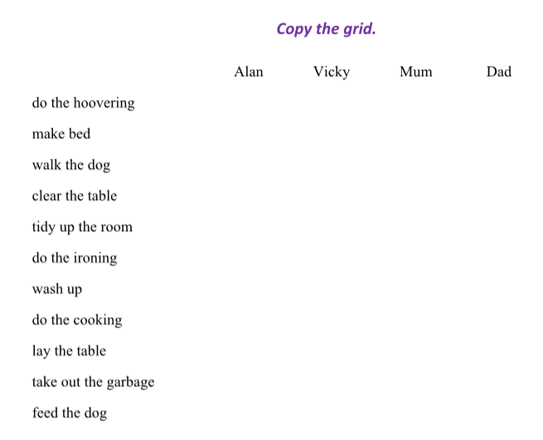

***6. Writing***

***Monday, the sixth of November  
Homework***

**Доповніть речення, використовуючи слова everyone, everything, everywhere, anyone, anything, или anywhere.**

1. I’ve looked for my bag ___________ but I can’t find it.

2. I didn’t meet ___________ new at the party.

3. Hi! Is ___________ OK? You look unhappy.

4. I got into trouble but I didn’t do ___________ wrong!

5. Baseball is played ___________ in Poland

6. The house is empty. There isn’t ___________ at home.

***7. Homework***

1. Опрацюйте конспект уроку;

2. Завдання із розділу Writing (письмово).

**Надіслати виконані завдання на освітню платформу Human або**

**на Viber (0964124047)– Людмила Григорівна.**

**Бажаю успіху!**